FOR GMAIL USERS

Please follow the instructions below to set up your email signature on Gmail!

Signature instructions:

Signature block: Please copy, paste, & modify

Firstname Lastname (they/them)
Your Title Goes Here
P: 1-(xxx) xxx-xxxx C: x-(xxx) xxx-xxxx
replacewithyouremail@blueantmedia.com
99 Atlantic Ave, Toronto, ON M6K 3J8


Email Signature instructions for GoogleMail:
1. Highlight the entire signature block above – including the logo! – and copy (Ctrl+c).

2. In Gmail, go to Settings (little gear icon in top right) > See All Settings > Scroll Down to Signature > + Create New

3. Type in a name for your signature, like "my 2026 signature" and click Create.

4. Paste (Ctrl+V) into the signature box where your cursor is blinking.

5. Edit the signature to include your own name, title, and office address. Pronouns and phone numbers are optional (if you aren't using them, delete the placeholder text). Do not delete or adjust the logo.

6a. To update to your email address, click the blue underlined text like so:
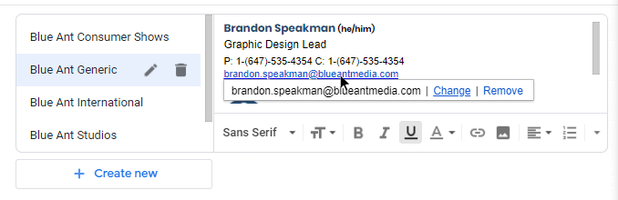

6b. Then select Change. Add your own email into both fields as below:
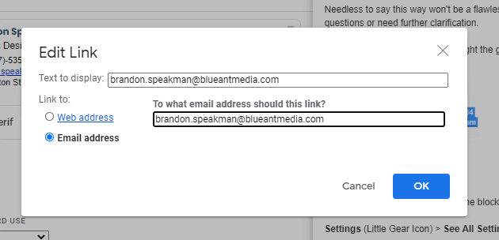

7. Under Signature defaults, select your new signature from both drop-down menus.
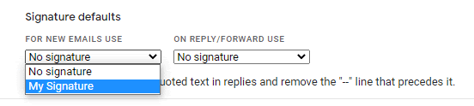
8. Click Save Changes at the bottom of the page and send yourself an email to test it out. You should be all set!

FOR OUTLOOK USERS

Email Signature Instructions for Office 365 (Outlook)

1. Highlight the entire signature block provided — including the logo — and copy it (Ctrl+C).
Firstname Lastname (they/them)
Your Title Goes Here
P: 1-(xxx) xxx-xxxx C: x-(xxx) xxx-xxxx
replacewithyouremail@blueantmedia.com
99 Atlantic Ave, Toronto, ON M6K 3J8

Outlook on the Web (recommended)
2. Go to Outlook.com and click the gear icon (top right)
→ View all Outlook settings
→ Mail → Compose and reply
3. Paste the signature (Ctrl+V) into the Email signature box.
4. Edit the text to include your name, title, and office address.
Pronouns and phone numbers are optional — delete placeholders if not used.
 Please do not delete or resize the logo.
5. Under Select default signatures, choose your new signature for:
- New messages
- Replies/forwards
6. Click Save, then send yourself a test email.
or

Outlook Desktop App (Mac or PC)
2. Open Outlook
→ File → Options → Mail → Signatures
3. Click New, name your signature (e.g. 2026 Signature), then paste the signature into the editor.
4. Update your personal details as needed (same guidance as above).
5. Set your signature as default for new messages and replies.
6. Click OK and send yourself a test email.

